

Lal Bahadur Shastri Institute Of Management Studies

Sector-11, Dwarka - 110075

ONLINE SHOPPING SYSTEM

Software Design Document (SDD)

Name (s): Aanandita (023)

Nisha Arya (036)

Akshay Solanki (031)

Date: 30/05/2020

**TABLE OF CONTENTS**

1. **INTRODUCTION**
   1. Purpose
   2. Scope
   3. Overview
   4. References
   5. Online shopping system
2. **SYSTEM OVERVIEW**
3. **SYSTEM ARCHITECTURE**
4. **DATA DESIGN**
5. **COMPONENT DESIGN**
6. **HUMAN INTERFACE DESIGN**

**1 INTRODUCTION**

* 1. **PURPOSE**

The objective of this project is to develop a general purpose e-commerce store where products can

be bought from the comfort of home through the Internet.

An online store is a virtual store on the Internet where customers can browse the catalog and select products of interest.

Users of this website will be able to create an account which will supply them with an easy to use interface in order to both purchase items listed by other users and sell items to other users. The basic requirements state that the users will be able to securely register and manage their profiles.

They will also be able to navigate through available items by category, or by using a well executed search function.

The selected items may be collected in a shopping cart. At checkout time, the items in the shopping

cart will be presented as an order. At that time, more information will be needed to complete the transaction. Usually, the customer will be asked to fill or select a billing address, a shipping address, a shipping option, and payment information such as credit card number.

Finally, a payment mechanism The website will be maintained and managed by administrators. They will have the authority to approve and reject requests for new products and maintain various lists of shop categories. The administrator will also be able to control customers and visitors actions.

* 1. **SCOPE**

For this project we want to define what will be done such that the final product meets expectations.

With this in mind, the following are the parts that will be completed:

• Secure registration and profile management facilities for customers

• Payment mechanism and gateway for all popular credit cards, checks and other relevant payment options.

In addition to the above mentioned basic functional requirements for the project, we plan for the following supplementary requirements as well. We will create a shopping cart so that the customers can save their items and checkout later with the entire shopping cart.

For maintaining the robustness of the system and also for the safety of customers and vendors, we will ensure following in the project:

• Overall system quality should be good and it should be a smooth experience for customers.

• The system should be easy to maintain. We will be using server side scripting languages

• Customers and vendors details will be secure from outside intruders.

• Safe payment gateways will be used and all the security checks will be made to ensure a safe deal.

• The system will remain up at all times. The hardware and software should be robust and will be tested extensively.

* This system allows the customer’s to maintain their cart for add or remove the product over the internet.They can browse any type of fashionable things from any brands.

1.3 **Overview**

The Online Shopping Mall will provide easy access to consumers to products from different vendors without having to walk into the particular stores. It will also help vendors by reaching out to more and more customers through internet. It will be a win-win situation for all.

The software will be designed to be easy to use with very good and intuitive CHI (Computer Human Interface) and reliability. It will be available to customers and vendors round the clock. The support will be added for every Operating System (Windows / UNIX / Mac) as it will be server side hosting. On-line shopping malls have become an essential link between products and customers.

* 1. **Definitions, Acronyms and Abbreviations**

oss-online shopping system

* 1. **References**

1 Book by Aggarwal K.K., Singh Yogesh, K.K. Aggarwal, and Yogesh Singh

2 Jalote, Pankaj. *An integrated approach to software engineering*. Springer Science & Business Media, 2012.

* 1. **Online shopping system**

1. **SYSTEM OVERVIEW**

This system involves its own database to be maintained. As the information or details about the products are stored in the database for the server side functionalities.

The Server process is for dealing with the customer’s detail and the items that are shipped to different locations based on the addresses provided by the customers.

The application design contains two modules one is for the customers who wish to buy the articles. And another is for the store owners who maintains and updates the information regarding the articles and about the customers.

The end user to use this product are the common people for whom the application is to be hosted on the web and the admin maintains the database.

The application that is deployed on the customer’s database, the information regarding the items are highlighted and forwarded from the database for the customer (front view) based on the choice through the menu list and based on all these searches and transactions the database of all the products are updated at the end of each transaction.

The entries for products, into the application, can be made through various screens designed for various levels of users. As soon as, the authorized personnel feeds the relevant data into the system, several reports are generated based on the security policy used.

Future scope :

Our designed online shopping system provides the 24×7 service, that is customers can surf the website, place orders anytime they wish to. Also, the delivery system works for 24×7 hours a week.

Some of the features that can be modified and added to this system in future involve its implementation by local shopkeepers, where shops will be providing an online interface to customers for shopping and placing orders.

Then some delivery persons can perform their work. This will be add on benefit for the customers as it will save their time, plus its add on for the shopkeepers also, as people will continue to shop from local shops rather than preferring to super markets every time.

Also since the deliveries from these local vendors will not be as time-consuming as these days Flipkart, Amazon etc. take, but rather will be delivered the same day of an order placed.

Else the shopkeeper can ask the customer that the product will be available by next day, so if he/she still wants to place the order, it can be done. Again return or exchange will be easy since the delivery boy can even do it as the store is nearby.

Including a chat box for public benefit is also a great idea via which people can directly have a conversation with some officials regarding any type of queries.

1. **SYSTEM ARCHITECTURE**

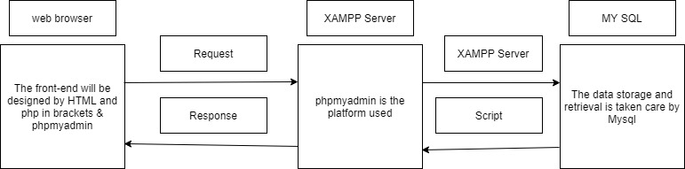

**languages used** : HTML and PHP

**server** : XAMPP for windows or LAMPP for linux(apache)

**database** : MySQL

**administrative tool for database** : phpmyadmin

**4. Data design**

The following gives the overview of all the tables involved in the online shopping system .

**Database : OSS**

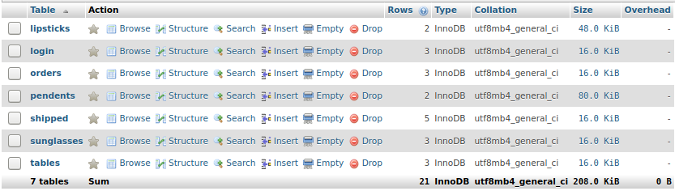

**Table : Tables**

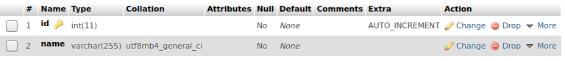

This table keeps the track of all the product categories in the database like cloths or accessories.

**Table : Sunglasses , lipsticks , pendents**

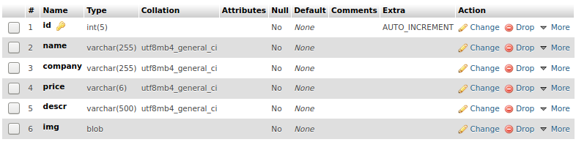

The following is representation of how each category table will look like

**Table : Login**

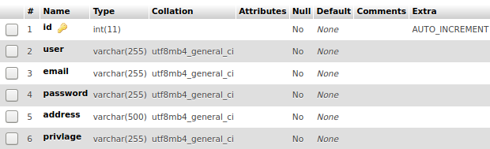 The table contains login information regarding id and passward. Also contains root privlages

**Table : Orders**

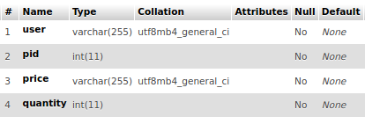

The table contains the id of the products and product information selected by the shopper along with shopper information

**Table : Shipped**

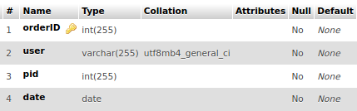

This table contains the previously ordered products by each shopper along with the order information

**USE CASE DIAGRAM**

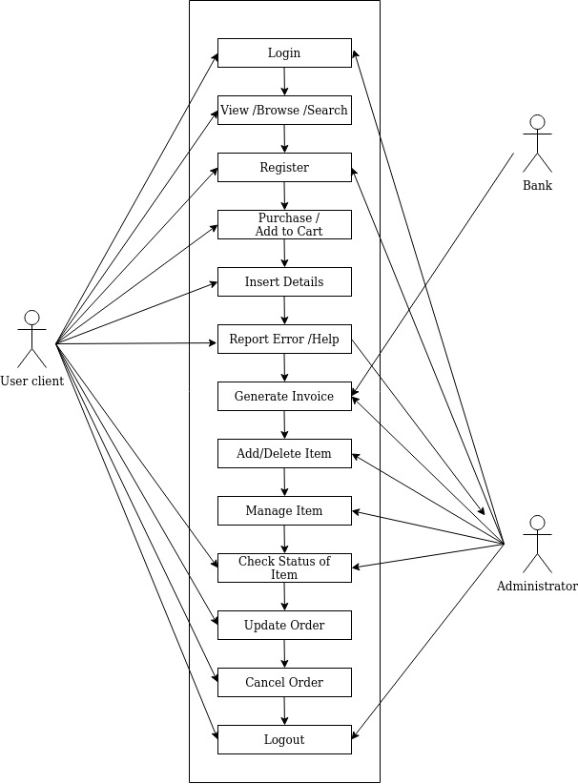

**DATA FLOW DIAGRAM**

**DFD LEVEL 0**

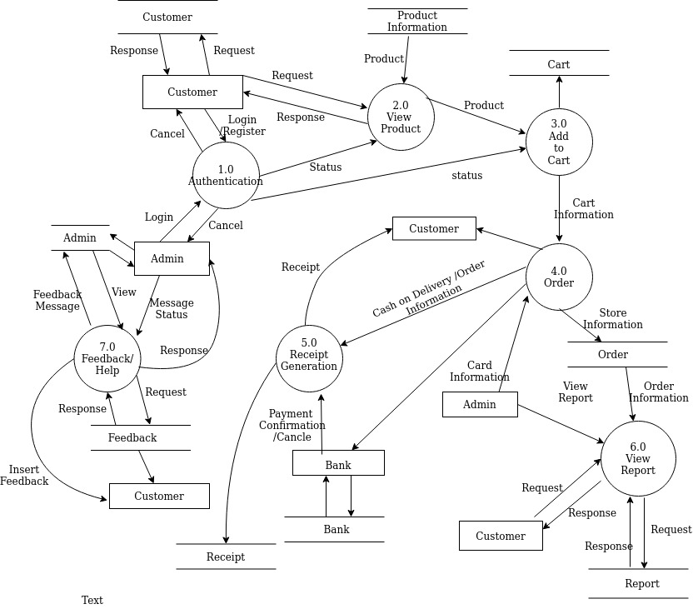

**DFD LEVEL 1**

**DFD components:**

**: Function**

**: Input/output**

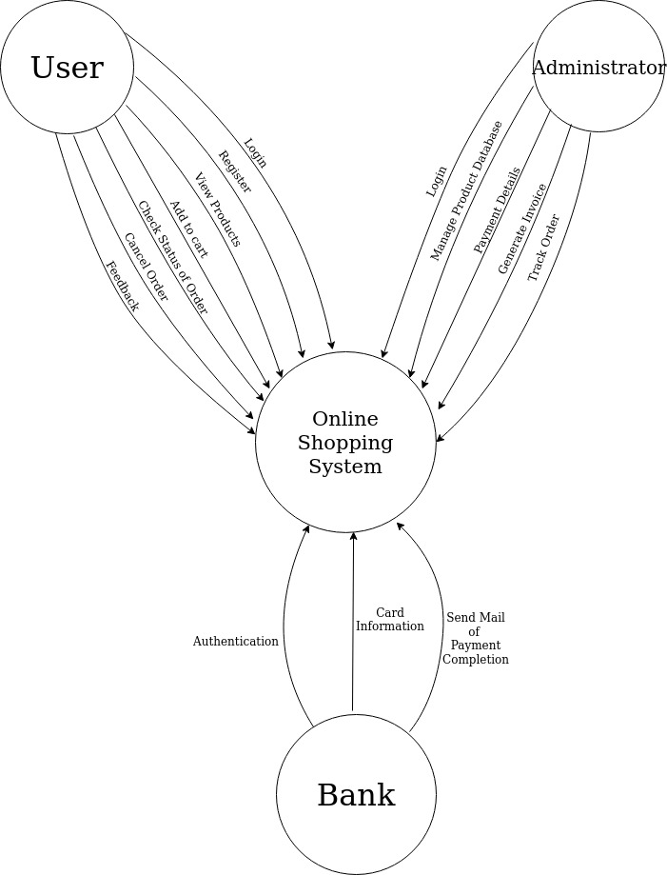 **: Flow**

**DFD LEVEL 2**

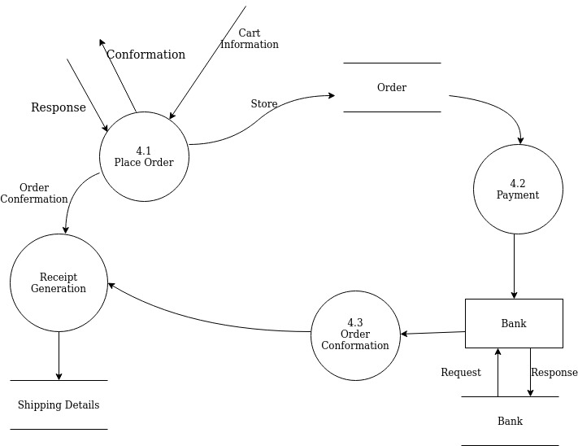

**5 COMPONENT DESIGN**

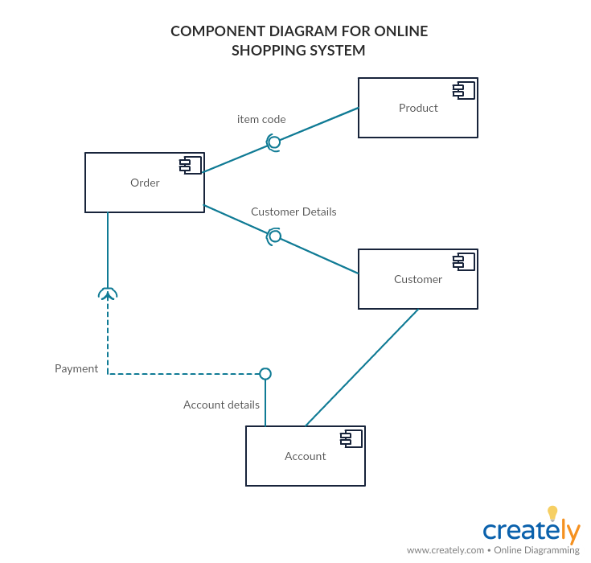

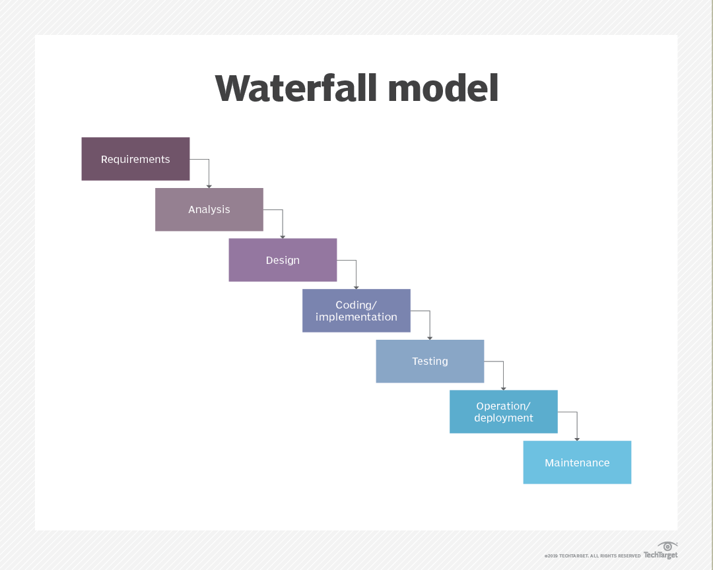

We use waterfall model for the implementation of our project

The waterfall software process is plan-drive model was used to implement the entire project. Advantages of waterfaJll process model :

* This model is simple and easy to understand and use.
* It is easy to manage due to the rigidity of the model – each phase has specific deliverables and a review process.
* In this model phases are processed and completed one at a time. Phases do not overlap. ➢
* Waterfall model works well for smaller projects where requirements are very well understood.

**6 HUMAN INTERFACE DESIGN**

**SCREEN IMAGES USER SIDE**

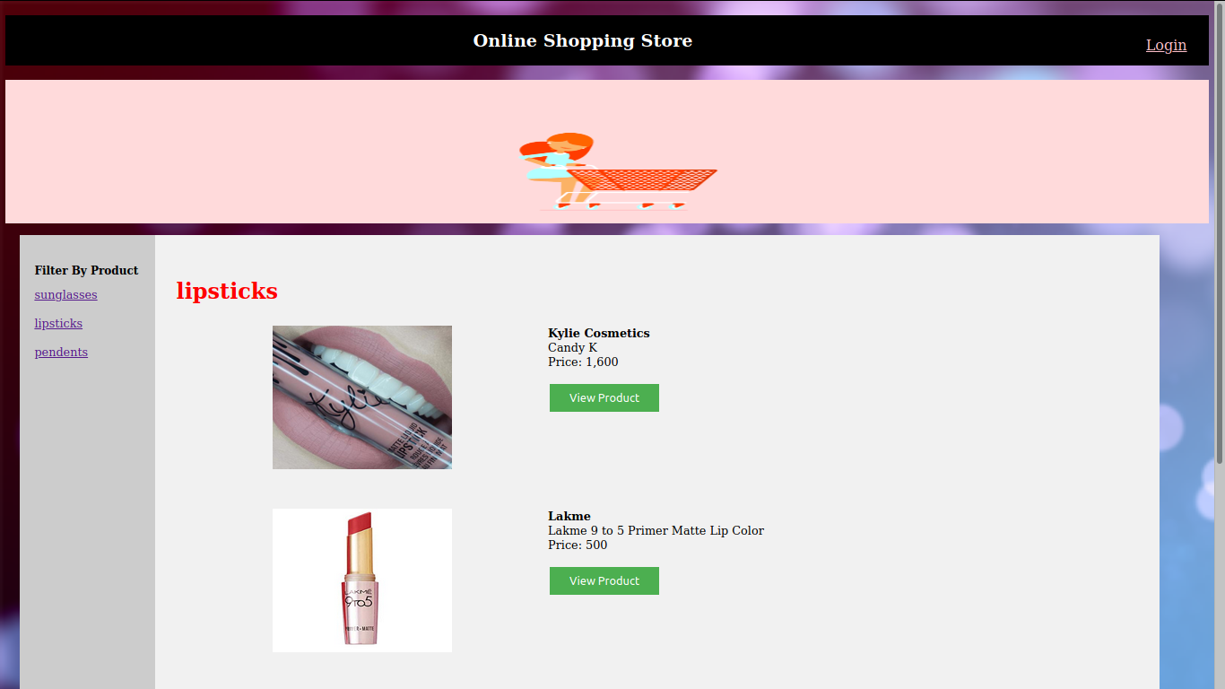

**Fig 1 : Homescreen**

This screen shows products in general . The user can browse on the left for categories he/she is interested in .

When you click other categories all the products of that category will show up

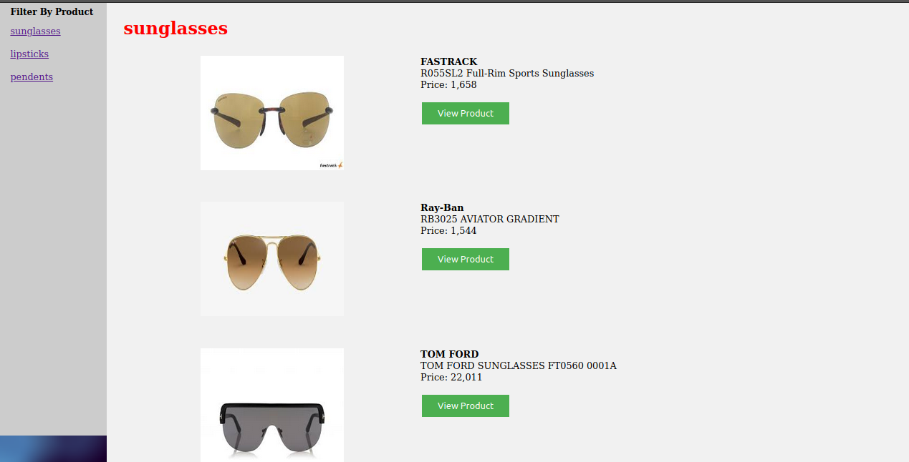**Fig 2 : product category – sunglasses**

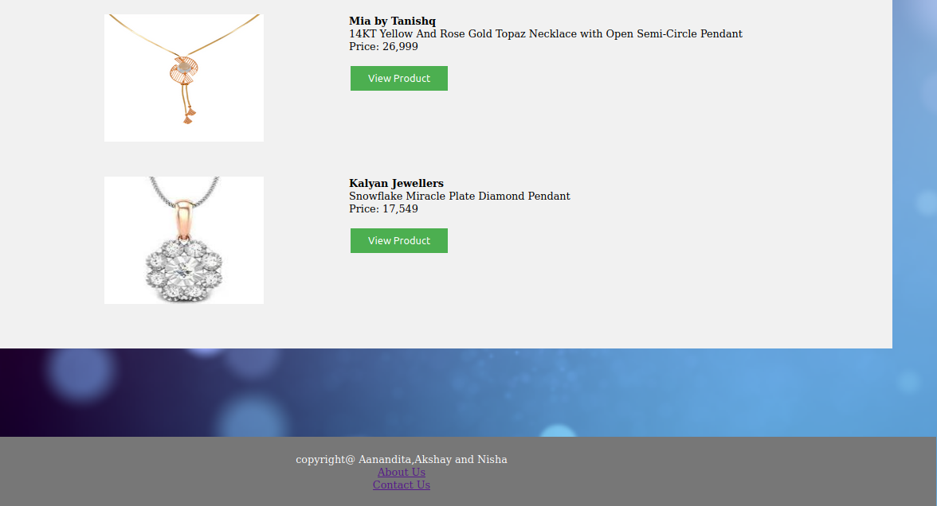**Fig 3 : product category – pendent**

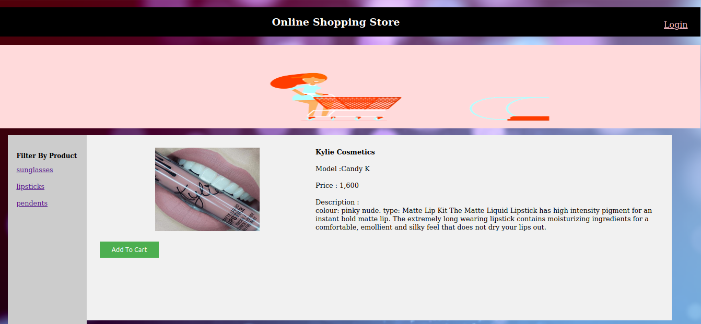

**Fig 4 : when you will click View product it will show the description of the product**

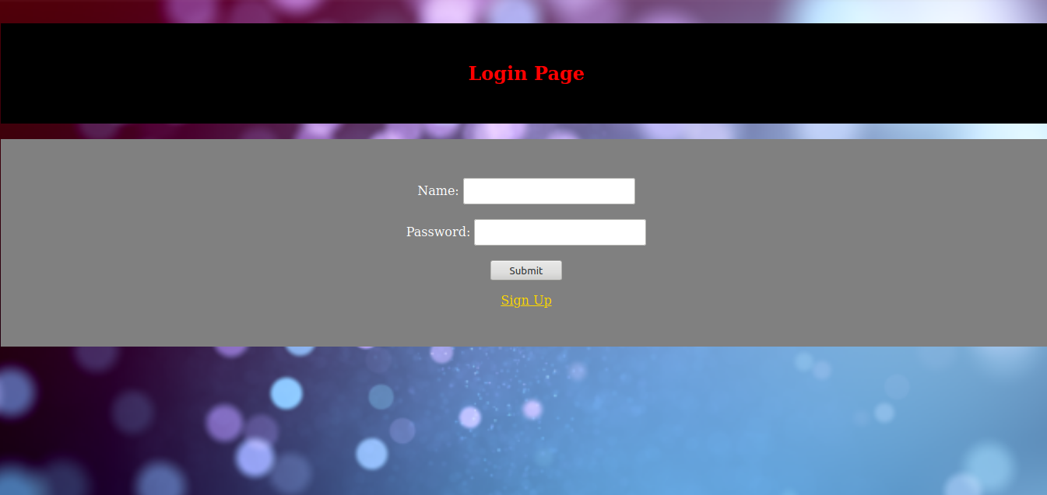**Fig 5**

If the user trys to add product to cart without login in first he/she will be redirected first to the login page here there are numerous checks placed :

* if the username exists but the password does not match there will be error of incorrect password
* if the username does not exist we will be directed to sign up page

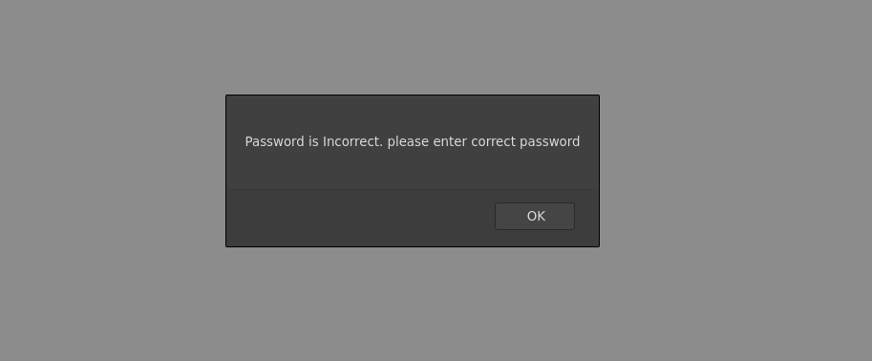**Fig 6 : login check alert**

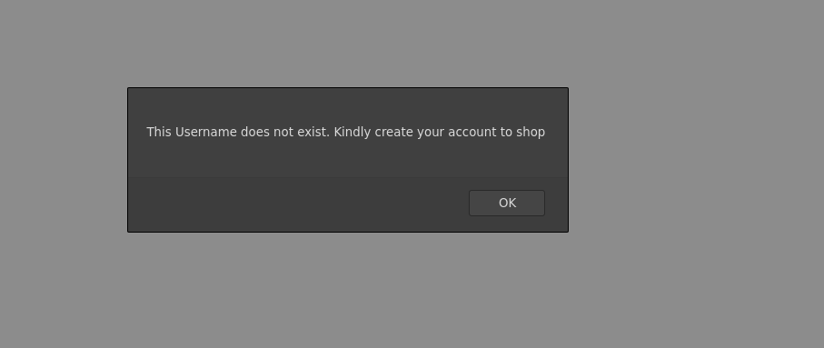**Fig 7 : Alert to sign up**

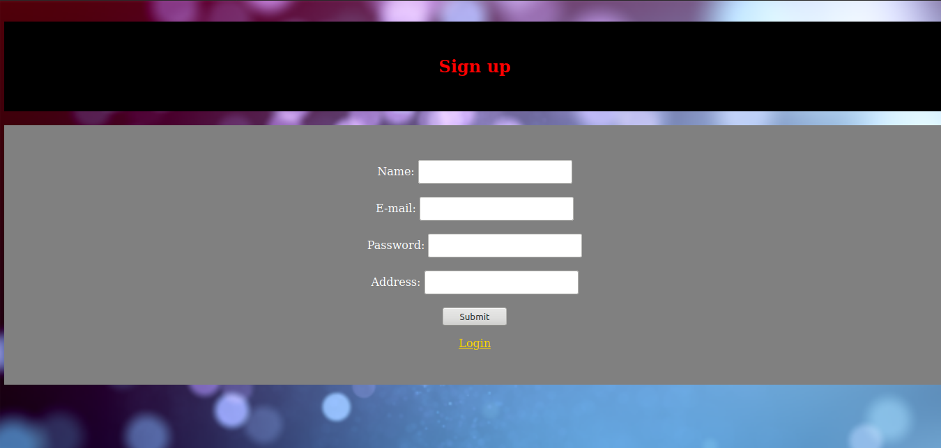**Fig 8 : Sign up page**

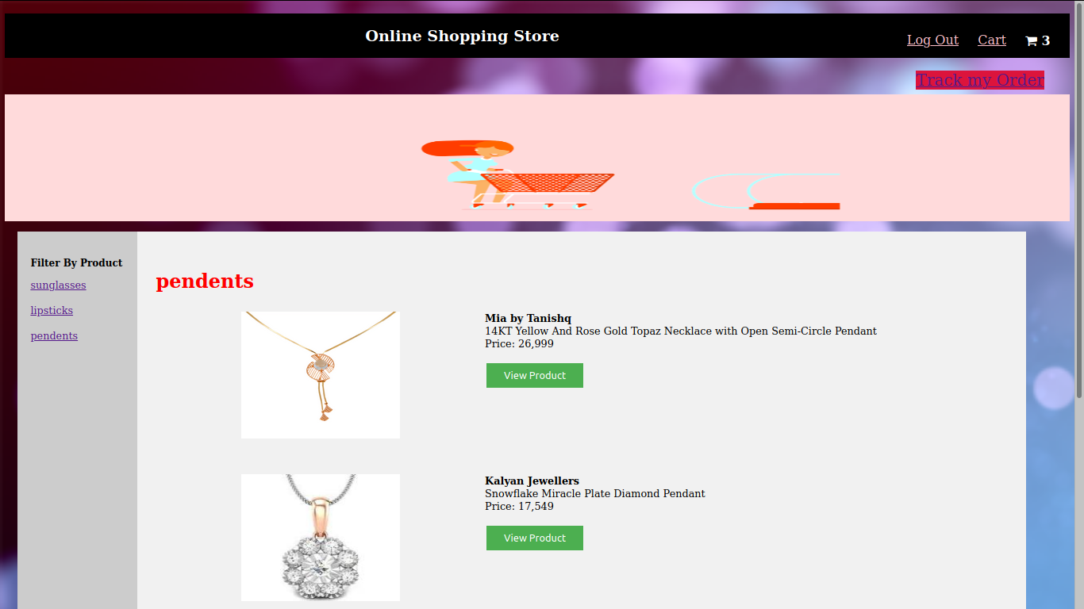**Fig 9**

After signing up the user will be directed to the main site the user will be given options of show cart, logout as well as cart displaying the amount of products currently in the cart .

Also the option to browse previously bought products will be avaiblable with track my order link .

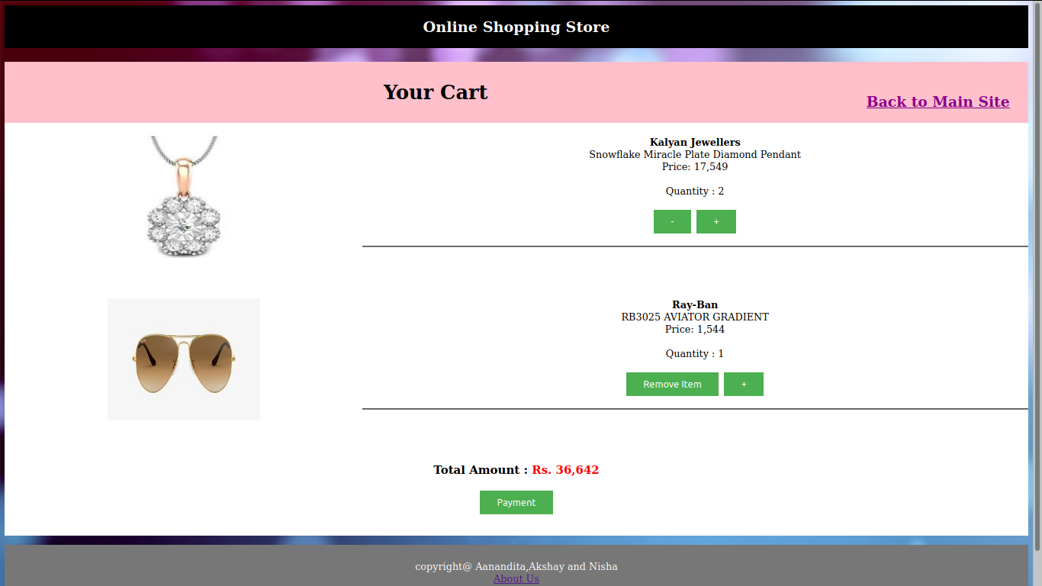**Fig 10 : Products added to cart for review before payment**

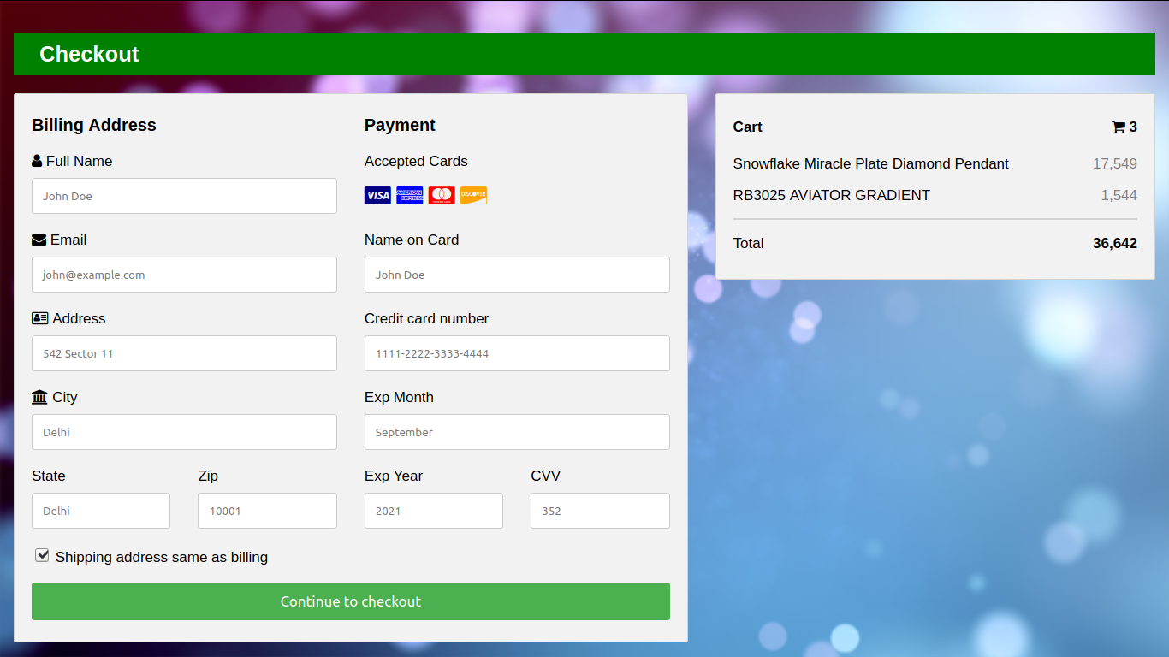

**Fig 11 : payment gateway**

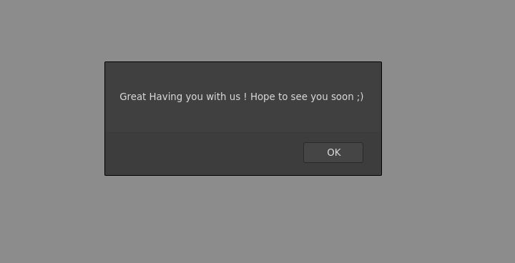**Fig 12 : alert after payment is made**

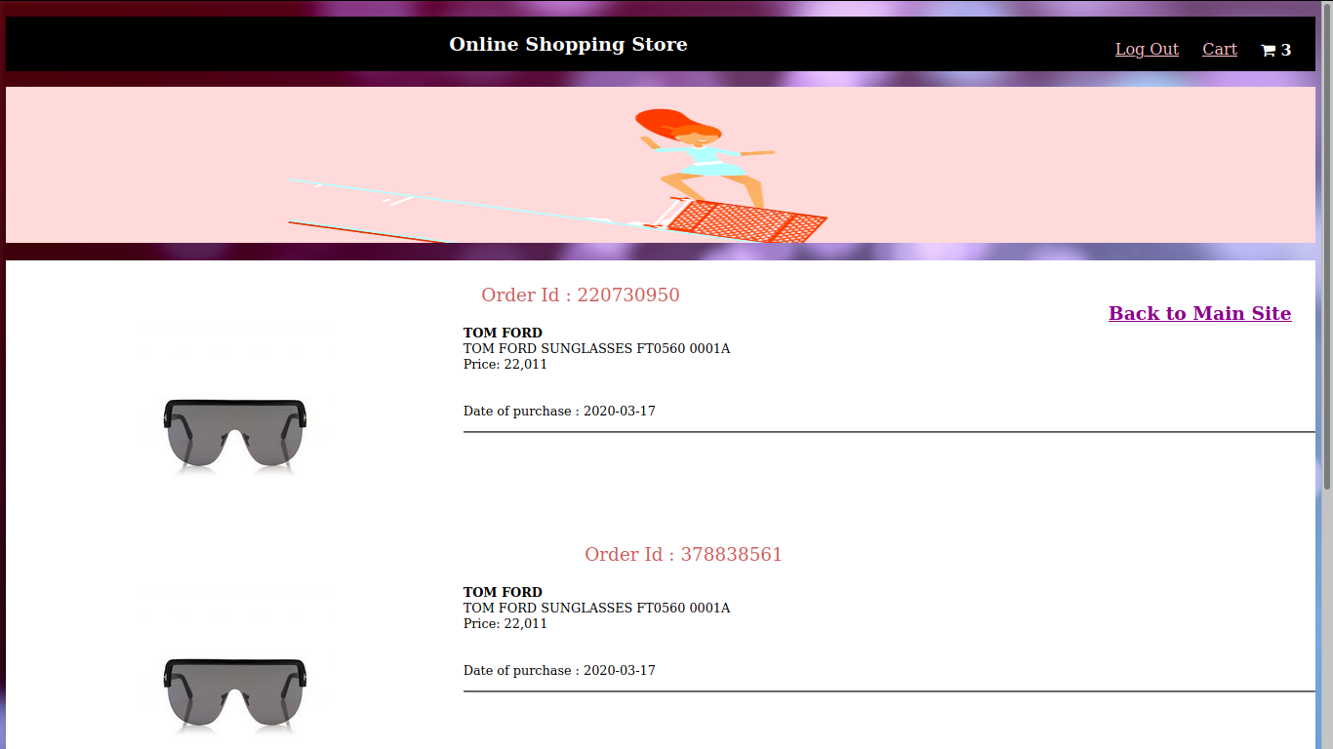**Fig 13 : orders placed**

**ADMIN SIDE**

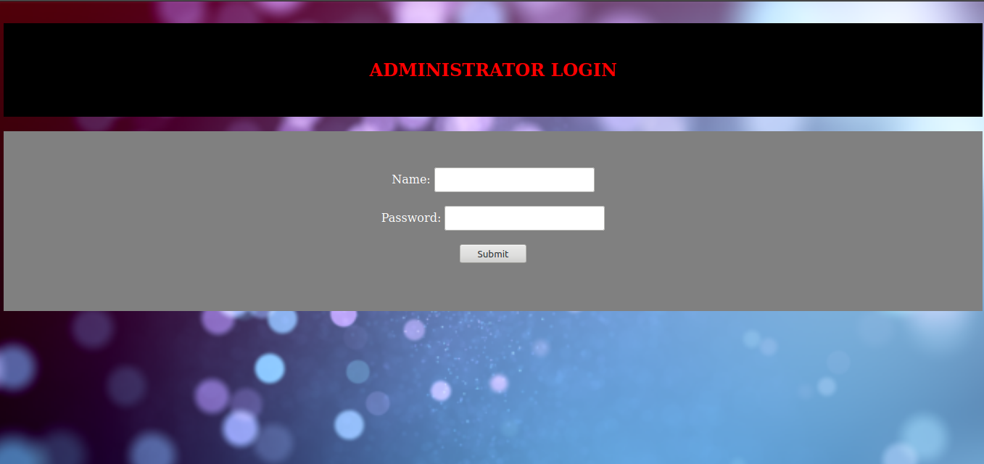**Fig 14 : Admin login**

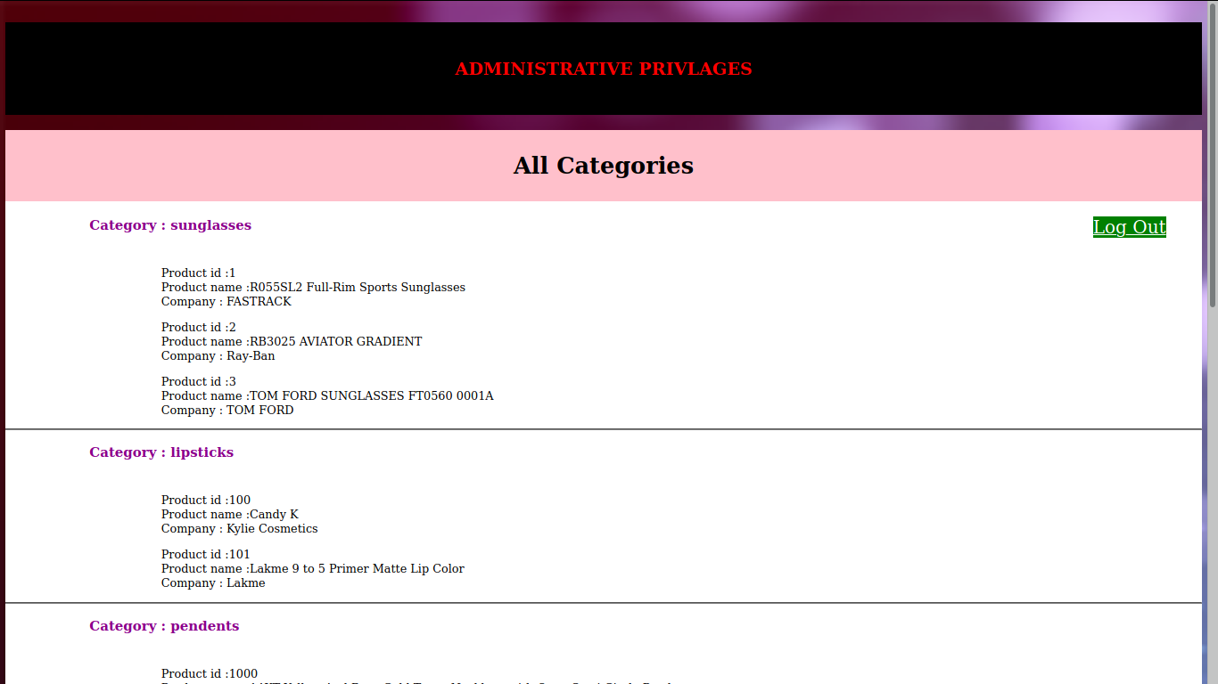**Fig 15 : adminstrative page displaying the inventory**

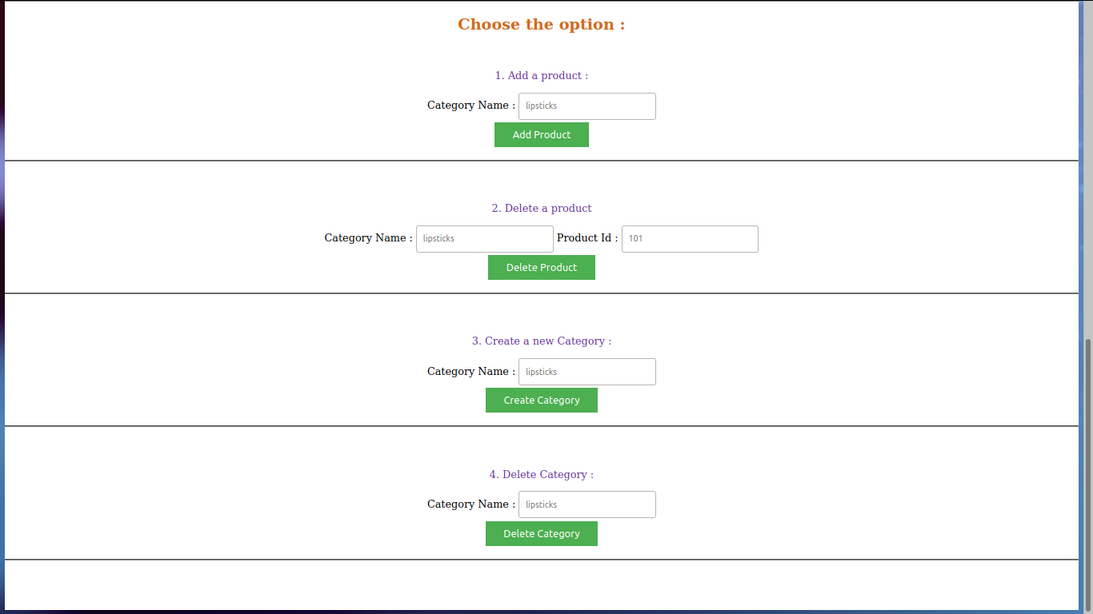

**Fig 16 : administrative page displaying options for adition or removal of new category or product**

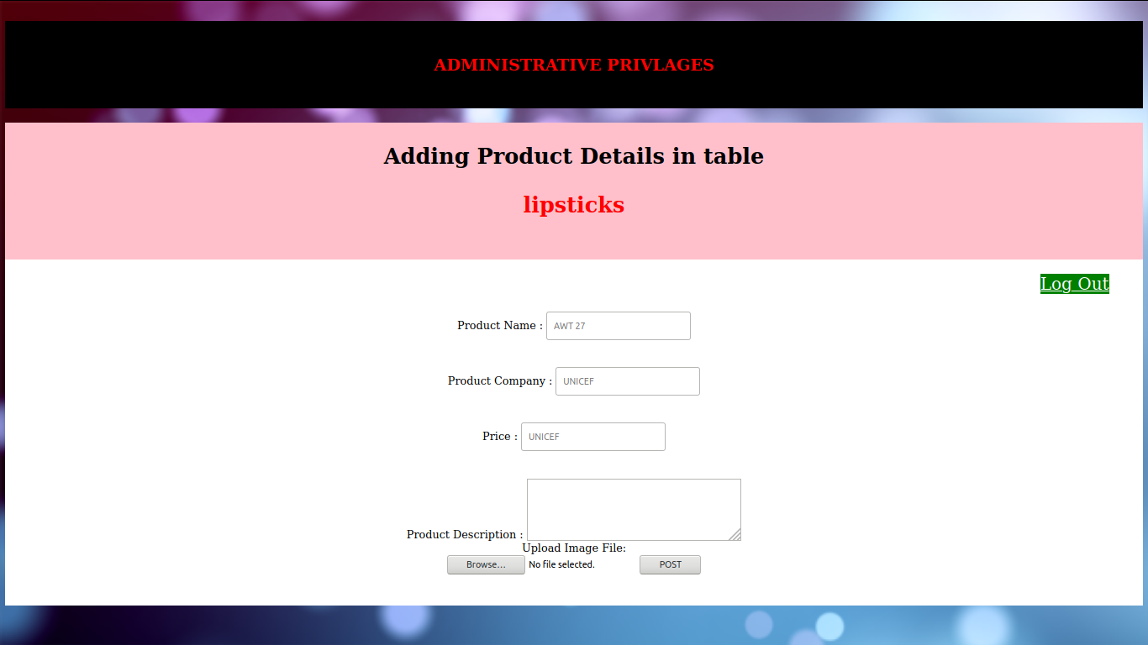

**Fig 17 : administraive page for addition of new product in a category**